**Proceedings of the ASME 2024**

**Heat Transfer Summer Conference**

**SHTC2024**

**July 11-14, 2024, Anaheim, CA, USA**

**SHTC2024-131904**

IMPROVEMENT OF A LOW-COST APPARATUS FOR MEASURING THERMAL CONDUCTIVITIES OF SOLIDS AT STEADY-STATE 

**Brandon Bunt, Kamau Wright, Benjamin Davis**

The Cooper Union, New York, NY

Abstract

*We have improved upon a low-cost instrumented heat transfer apparatus to measure the thermal conductivity of materials ranging from as high as 398 Wm-1K-1 down to 5 Wm-1K-1 using steady state methods. Samples include copper, aluminum, brass, alumina ceramic, stainless steel, thermally conductive silicone, and photopolymer resin. The system was developed as part of a previously published study* [1] *detailing development of a low cost linear heat conduction module (LHCM) that approximates one dimensional heat transfer through a stack of cylinders of material. At the center of the LHCM, a sample material is placed between two cylinders of brass of a known thermal conductivity. By maintaining an isothermal boundary layer on the bottom side of the LHCM, applying constant energy through an electrical resistance heater on the top side, and waiting for steady-state, the thermal conductivity of the sample material can be calculated from a recorded temperature difference.*

Keywords: Place any keywords here

Nomenclature

k thermal conductivity

LHCM Linear Heat Conduction Module

D, d Diameter

STP Standard Temperature and Pressure

OD Outer Diameter

Mass Flow Rate [kg/s]

qz Heat Flow *(in the z direction)*

T Temperature

TD Temperature from Thermocouple D

TE Temperature from Thermocouple E

ΔT Change in Temperature

1. INTRODUCTION

A LHCM is an experimental apparatus that approximates one dimensional heat transfer through a stack of cylinders of material. At the center of the LHCM, a sample material is placed between two cylinders of brass of a known thermal conductivity. By maintaining an isothermal boundary layer on the bottom side of the LHCM, applying constant energy through an electrical resistance heater on the top side, and waiting for steady-state, the thermal conductivity of the sample material can be calculated from a recorded temperature difference. This study follows up on previous work by authors to develop a low-cost instrumented heat transfer apparatus for measuring thermal conductivity using steady-state methods.[1] In that study, a Linear Heat Conduction Model (LHCM) was developed for under $2000, which includes costs and estimates of actual materials purchased and those materials already accessible. The original LHCM could measure the thermal conductivity of materials with k-values ranging from 115W/mK to 167W/mK within 4% accuracy of literature values.

The present study seeks to experimentally demonstrate the range of thermal conductivity values that can be assessed with this instrumented apparatus.

A key interest in linear heat conduction modules is in assessing thermophysical properties of low conductivity materials. The work here aims to (1) experimentally demonstrate the capabilities to assess thermophysical properties of materials of a range of conductivities; (2) experimentally explore the limitations of assessing materials of lower thermal conductivities; and (3) propose alterations to the approaches used, that would allow for assessment of low-k materials within a limited range of uncertainty (under 10%). Alterations considered include consideration of the impact of geometry and dimensions of the apparatus, potential use of guarded hot plate approach, and vacuum insulation. Models will also be presented to describe the anticipated results. Assessing low conductivity materials presents challenges, among them low accuracy due to heat lost from the heater to the surrounding environment can cause the system to experience a boundary condition that is not constant, making it unable to maintain a large enough temperature difference While assessing lower conductivities is a driver of the work performed here, higher conductivity materials such as copper are also tested. Currently, the LHCM also demonstrates low accuracy (above 10% greater than 398W/mK) with high conductive materials like copper (398W/mK), attributed to the need to measure small temperature differences over small distances, and deviations from equilibrium due to changes in the cooling loop temperatures.

In our previous work, we demonstrated that the low-cost LHCM made with machined sample materials and off-the-shelf components for a data acquisition system could measure the thermal conductivity of Brass 360 within 4% (measured 119W/mK). Additional testing with the same apparatus has measured thermal conductivity of other metals, such as aluminum 6061, within an uncertainty of 5.6% (measured 167 W/mK). We anticipate that the accuracy of the LHCM for measuring thermal conductivity of materials on the order of 10W/mK to be approximately +/- 10%.

1. **IMPROVEMENTS TO THE SYSTEM**

Improvements to the LHCM ranged from procedural improvements to physical changes in the system. Some simple improvements involved changing components of the LHCM to newer off-the-shelf components. For example, a newer, more accurate Watt-meter (Watt measuring device, like an electrodynamometer) was used for monitoring the input q from the variac transformer.

* 1. **Data Acquisition System Improvements**

Mounted data acquisition system (mounting the microcontroller, also to avoid pulling with thermocouples)

**2.2 Adjustment s to Thermocouples**

All thermocouples were standardized to be 20in. long to prevent situations where thermocouples tugged on the data acquisition board. The thermocouples do not have a circular cross-section due to the two wires that are next to each other. To fit well, The thermocouples’ fiberglass sheath was carefully cut around each tip to ensure a snug friction-fit in the brass.

In some instances, adding heat shrink tubing around the ends of the thermocouples, as well as the connection point of the thermocouple to the MCP9601’s terminal block improved the reliability of data collection, as well as ensuring fiberglass debris does not harm lab occupants. To facilitate ease of removal before and after testing, a slip fit was machined out of the insulation as well as the 60mm long brass conduction paths and 30mm long sample pieces. A slight chamfer was added to the hole for thermocouples on the PTFE insulation for ease of insertion. In the previously published paper, thermocouples were cut by hand, which resulted in frayed edges. This not only causes skin irritation, but it can also cause inaccurate fluctuations in data because of contact between the two metals within the thermocouple in undesired locations. Heat shrink was added to the ends of the thermocouple, as well as the connection to the terminal block on the MCP9601.

|  |  |
| --- | --- |
|  |  |
|  |
| (a) | (b) |

**FIGURE 1**: THERMOCOUPLES ENDS HAVE AN IMPACT ON THE MEASUREMENTS: (A) TWISTED AND LOTS OF WIRE EXPOSED; B) WELDED AND ONLY THE JUNCTION IS EXPOSED.

On the top right is a type T thermocouple for surface contact measurement with a twisted end, and on the bottom right is a type K thermocouple with a welded tip. Although the type T thermocouple is more resistant to noise due to its twisted tip, temperature is recorded from the point of first contact between the two metals that make up the thermocouple. In this case, the left type T thermocouple will record temperatures at the bottom twist, where the green shrink wrap ends, and the exposed metal begins. When inserted into the holes along the LHCM, this area aligns with the PTFE insulation, instead of the sample to be measured. This can result in incorrect readings, as the thermocouple will output the temperature of the PTFE or the local air directly around that point instead of the center of the sample. Once this was determined, all the thermocouples were adjusted to only feature two or three twists and were wound as tight as possible to allow the twisted portion of each thermocouple to reach the inner center of the sample.

To ensure accurate temperature measurement, thermocouple tips were pushed all the way to center axis of LHCM, by pushing them all the way in and taking advantage of the friction between the thermocouple’s fiberglass sheathing and the PTFE to secure them in place.

Additionally, to ensure only the very tips of the thermocouples were exposed, the fiberglass sheathing was cut close to the tip, and all thermocouples tips were welded. Frayed fiberglass was carefully removed with a sharp blade or scissors

* 1. **System Insulation**

A PVC tube with a 2.5 inch inner diameter was cut to 12.5 inches to act as an additional insulative layer. Since the diameter of the PTFE insulation is 2 inches, a 0.5” ring of still air was effectively created around the central LHCM column. This still air provided additional insulation.

Additionally, a 0.32 inch thick ring of brass was removed from the original brass heater shroud to add a layer of still air for improved insulation. The LHCM with the original brass heater shroud would reach surface temperatures on the PTFE above 70°C around the top portion that housed the heater. After this modification, temperatures at the same location stayed between 30-36°C.

* 1. **Ice Bath and Isothermal Boundary Layer**

To monitor the temperature of the ice bath, a handheld thermocouple reader and two NPT ¼” threaded k-type thermocouples was used to compare the inlet and outlet temperature of cold water loop.

Ice was monitored visually to ensure most had not yet melted. Throughout the duration of each experiment, ice was continuously added to the bath.

* 1. **Combating Contact Resistance**

1. Thermal paste was applied between each sample and brass conduction paths. For every new test, fresh thermal paste was applied on either side of the sample.

2. For samples that produce an oxide layer, such as stainless steel, the sample was thoroughly scrubbed with an abrasive sponge to remove the oxide layer.

1. **MATERIALS AND METHODS**

All materials and methods that have been used in the work must be stated clearly. Subtitles should be used when necessary.

**FIGURE 2 –** CROSS-SECTION SCHEMATIC OF LHCM WITH TEST SECTION “DE”

**3.1 Procedure**

First, we verify that the data acquisition system is correctly saving data via serial communication at a rate of 115200 baud by observing the live monitor in Serial Studio and confirming all thermocouples read room temperature. Then, all thermocouples are calibrated with an ice bath. An ice bath is prepared by placing the sump pump inside the cooler and carefully filling it with ice as tightly as possible. This ensures that the ice bath achieve a value as close as possible to 0°C throughout the ice bath container. Subsequently, water is added into the cooler to fill the gaps between the ice and pump.

Next, each section of the LHCM is stacked on top of each other to assemble a conduction tower, resembling figure 2. Before stacking each piece, thermal paste is applied to the top face of each section. For example, before the bottom conduction path that houses thermocouples F, G, and H, is placed on top of the cooling loop, thermal paste is applied to the top face of the cooling loop, and then the bottom conduction path is placed on top. Force is slowly and carefully applied until it is clear the PTFE insulation has snapped together. The PTFE insulation features protruding and recessed geometry that allows each section of the LHCM to snap together. During this step, it is sometimes necessary to use a scour pad to remove any deteriorated or dried thermal paste from previous experiments on the faces of the brass conduction paths or sample materials. If a sample material different from the previous experiment is being tested, force is applied gently on the sample material until it is removed from the 30mm long PTFE insulation sleeve. Thermal paste is freshly applied to the top face of the sample, and it is stacked on top of the bottom conduction portion of the LHCM.

The separate sections of the LHCM assembled together can be referred to as the “conduction tower”. The insulative PVC tube is placed over the tower. The LHCM is viewed from above to ensure the PVC tube is concentric with the conduction tower. Next, all thermocouples were fastened inserting the thermocouple through the insulation sleeve and into the center of the cylindrical conduction tower until the thermocouple could not be pushed in further. Markings can be made 0.5” from the tip of each thermocouple to verify that it reaches the center of the conduction tower.

Next, the insertion heater is powered to the desired input power, qin, with a variable transformer and wattmeter. The PID controller’s alarm should be set to 200°C, well below the melting point of the PTFE, 260°C (500°F). If the PID controller turns off the insertion heater, the user must stop collecting data and wait until the PID controller turns the heater back on, and the system achieves a steady state again. This is because once the heater is off, the system no longer has a constant heat flux, and therefore the Fourier equation cannot be used to solve for k. In future iterations of the LHCM, other machinable ceramic insulations may be considered to achieve similar thermal isolation from surroundings, good tolerance, and resistance to high temperatures.

After the user verifies all components of the LHCM are operating correctly, they must wait until the system reaches steady-state. The steady-state criteria of this study required fluctuations no greater than ±0.5°C for at least 5 minutes. During the time it takes for the LHCM to reach steady-state, ice is regularly added to the ice bath as needed. This can be done by manual observation of the amount of ice left in the ice bath, as well as by comparing the temperatures of the outlet to the inlet of the cooling loop. Large differences of temperature between the inlet and outlet can be mitigated by removing some water with a container, adding ice, and agitating the ice bath to ensure an even distribution of ice, and consequently a consistent temperature. The steady-state temperatures of thermocouples D and E are then recorded and used to calculate the k-value of the sample material.

**3.2 Material Composition and Effect on Thermal Conductivity**

While textbook sources often provide thermal conductivities of pure metals and materials, many pure materials are difficult to source and not commonly used. For this reason, commonly used alloys, such as SS304 for stainless steel and C11000 for copper were chosen to be tested in the LHCM. In some cases, such as with copper 110, the composition must be at least 99.9% Copper to be considered alloy 110. [2] In other cases, standards set by professional organizations require a range for composition of metals within the alloy. For example, for Stainless Steel Alloy 304, SAE and AISI set a target percentage of 18% Chromium and 8% Nickel, however permit a range for each. [3] Organizations such as NIST have tested the thermal conductivity of such alloys from 0K-300K. [4] Although the LHCM in this paper tests samples at a temperature higher than 300K due to the electrical resistance heater, these data points provide a good benchmark for determining the accuracy of the LHCM. Other manufacturers and online sources estimate a k-value for Stainless Steel 304 measured at temperatures above 300K to be 16.2 W/mK.

**3.3 Sample Preparation**

**Alumina Ceramic**

Aluminum Oxide, commonly known as Alumina, (Al2O3) can be synthetically produced to resemble naturally occurring Aluminum Oxide, known as corundum. Typically, components made from alumina are formed while the ceramic is still in its green, unfired state. After alumina has been fired, diamond tipped cutting wheels and grind wheels are required to cut alumina due to its high hardness. To create a 30mm long sample with two 0.09” diameter holes for thermocouples, a 1ft long rod of 1” diameter alumina was first cut with a waterjet cutter that utilized high-pressure water mixed with garnet abrasive, using techniques recommended by a study published in 2018. [2] Roughly, 6 lbs. of garnet was required to make a clean cut of a 1” diameter rod. The abrasive caused an uneven surface at the end opposite of the waterjet cutter nozzle, as shown in the figure below:

<insert image of alumina rod cut>

Once it was determined that polishing would be required, a diamond tipped cutting wheel and grinding wheel were used to achieve a flat polished surface.

Since holes for thermocouples would be prohibitively expensive to make, temperatures were measured on the top and bottom surfaces of the alumina, exactly 30mm apart. This was accounted for during calculations of the k-value. Customized brass conduction paths with channels for the

<insert image of brass>

<insert modified diagram>

**Thermally Conductive Metals**

Sample preparation for metals (aluminum, copper, stainless steel consisted of machining 1” rods to 30mm (1.181”) lengths.

**Stainless Steel 304**

Tested the stainless steel sample 10/20, but need to reapply fresh thermal paste for better results, as there is a very large gap in temperatures between sections of the LHCM.

Oxide layer formed on the surface of the stainless steel 304 sample increases contact resistance, resulting in increase in error.

About Alumina samples and tests (as of 10/19):

The alumina sample was polished by a machinist

Channels were placed in a backup brass conduction path

**3.4 Data Acquisition System and I2C Communication**

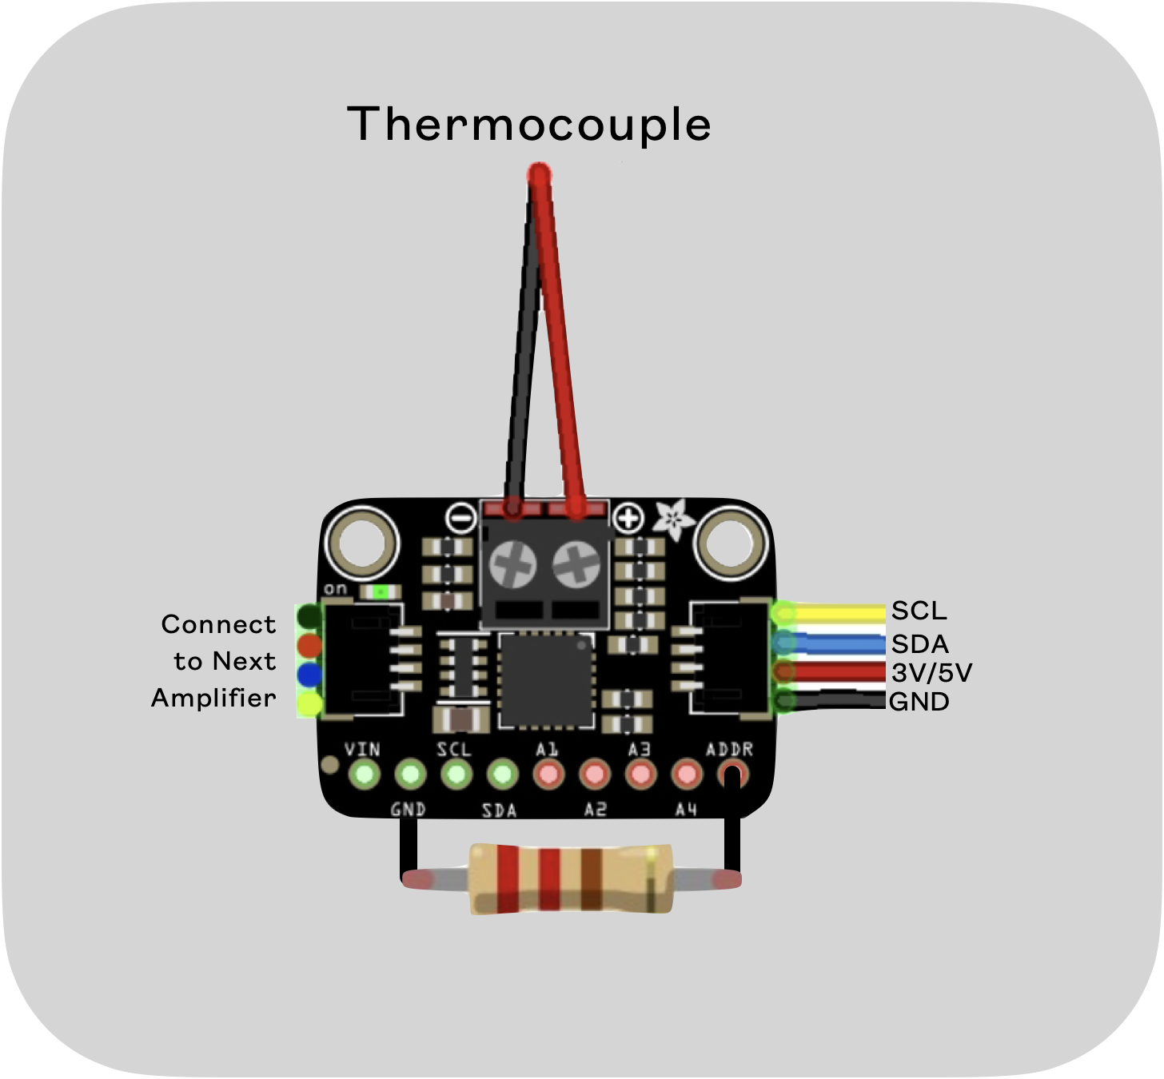

Figure : WIRING OF A MCP9601 THERMOCOUPLE AMPLIFIER

For ease of set up, data collection, and use of the LHCM, thermocouple signal amplifier chips from Adafruit, MC9601 with I2C capability were used. Eight MCP9601 chips can be wired in series, and with different resistances applied to the “address” pin, can be discerned. Wiring of resistors for I2C addressing is demonstrated by a 2.2kΩ resistor in figure 3. MCP9601 chips feature two solder pads on the back of the chip that enable the user to emulate adding 14kΩ (5th) and 22kΩ 6th resistors. Below is a table of resistances used to achieve a signal from the rest of the boards.

**TABLE 2:** WIRING DESIGNATIONS OF THERMOCOUPLES TO SIGNAL AMPLIFIERS

|  |  |  |  |
| --- | --- | --- | --- |
| Thermocouple | I2C Address | Command Byte | External Resistance  Applied [kΩ] |
| A (Cool Side) | 0x60 | 1100 000x | ADDR Pin to GND |
| B | 0x61 | 1100 001x | 2.2 |
| C | 0x62 | 1100 010x | 4.3 |
| D (Sample Bottom) | 0x63 | 1100 011x | 7.5 |
| E (Sample Top) | 0x64 | 1100 100x | 13 |
| F | 0x65 | 1100 101x | 22 (soldered jumper pad) |
| G | 0x66 | 1100 110x | 43 (soldered jumper pad) |
| H (Hot Side; closest to heater) | 0x67 | 1100 111x | ADDR Pin to VDD |

1. **RESULTS AND DISCUSSION**

Place results and discussion here. *Authors should make sure that all tables, graphics, and equations fit within the columns and do not run into the margins.* All figures, graphs, tables, etc. should be numbered. Ensure that all text is in black and that there is no highlighted text.

**4.1 Results by Material**

**ANTICIPATED RESULTS:**

It is expected that materials with thermal conductivities at and above that of cartridge brass (110W/mK at 300K) can be determined in under 40 minutes within 4% of their actual values. A model will be presented to predict and characterize results. It is anticipated that materials with thermal conductivities on the order of that of stainless steel (14.9 W/mK) can also be determined, but that materials with thermal conductivities at or lower than the insulation material of the current module (i.e., PTFE) on the order of 1 W/mK and lower will require significant alterations to the LHCM, or even a completely different approach such as use of a guarded hot plate and/or vacuum insulation. Future studies will clearly outline differences in design.

**ALUMINUM RESULTS:**

Preliminary testing with a stock 6061 aluminum sample gave a thermal conductivity of 131.01 W/mK after waiting 33 minutes for steady state. 6061 Aluminum has a literature value for thermal conductivity of 167 W/mK at 298.15K (25°C).

**CURRENT RESULTS:**

An early test done with a copper sample showed that Thermocouple G reached higher temperatures than thermocouple H, which should be recording the hottest temperatures since it is the closest to the electrical resistance heater. Later it was found that the two metals within Thermocouple H were in contact not at the center of the sample, but rather where the thermocouple is in contact with the PTFE.

**4.2 Measurement Accuracy Compared to Literature Values (as a function of k-value)**

Subtitles should be bold but not all-capped.

**4.3 Sources of Error**

One of the largest sources of error is heat lost from the system, through the PTFE insulation, to the surroundings. Using the known thermal conductivity of Brass 360 and PTFE, an estimate for heat loss can be analytically determined.

<will include analysis here>

**4.3 Uncertainty Analysis**

**FIGURE 4:** BAR CHART COMPARISON BETWEEN LITERATURE AND RECORDED K-VALUES WITH UNCERTAINTY

**4.4 Limitations of the LHCM**

**FIGURE 5**: FUNCTION OF RECORDED TEMPERATURE DIFFERENCE AND K-VALUE

This graph plots the recorded temperature difference between two thermocouples 5 mm away from each other within the sample material against the thermal conductivity of the sample, when 5W of power is supplied to the insertion heater. The region shaded in green is the ideal range for measuring thermal conductivity given system limitations, the primary limitation being the system’s ability to hold a temperature difference at steady-state.

**FIGURE 1:** PERCENTAGE OF PAPERS THAT SHOULD BE FORMATTED CORRECTLY  
  
Equations should be numbered (1), (2), (3), and so on, with the number flush right in the column and a space before and after the equation, like this:

(1)

1. **CONCLUSION**

Place 3-4 line conclusion here.

**ACKNOWLEDGEMENTS**

The authors acknowledge Isabella Flynn, Daniel Kim, [] for their data collection using LHCM.

**REFERENCES**

|  |  |
| --- | --- |
| [1] | B. K. Bunt, K. Wright and B. Davis, "Developing a Low-cost Instrumented Heat Transfer Apparatus for Measuring Thermal Conductivity Using Steady-State Methods," in *IMECE*, New Orleans, 2023. |
| [2] | S. Saurabh, T. Tiwari, A. Nag, A. Dixit, N. Mandal, A. Das, A. Mandal and A. K. Srivastava, "Processing of Alumina Ceramics by Abrasive Waterjet- an Experimental Study," Vols. 5(9, Part 3), p. pp. 18061–18069, 2018. |
| [3] | T. L. Bergman, A. S. Lavine, F. P. Incropera and D. P. DeWitt, Fundamentals of Heat and Mass Transfer, Wiley, 2017. |

**LIST OF FIGURES**

Figure 1: Thermocouples ends have an impact on the measurements: (a) Twisted and lots of wire exposed; b) Welded and only the junction is exposed. 2

Figure 2 – Cross-Section Schematic of LHCM with Test Section DE 3

Figure 3: WIRING OF A MCP9601 THERMOCOUPLE AMPLIFIER 4

Figure 4: BAR CHART COMPARISON BETWEEN LITERATURE AND RECORDED K-VALUES WITH UNCERTAINTY 5